**package** phase_three;

**import** javax.swing.JOptionPane;

**import** java.io.*;

**import** java.util.*;

**import** java.text.*;

**public** **class** phase_three

{

**public** **static** **void** main(String[] args)

{

//Patient parallel array

**int**[] pnumber=**new** **int**[100];

String[] pfirstname=**new** String[100];

String[] plastname=**new** String[100];

**double**[] paccountbalance=**new** **double**[100];

**int**[] page=**new** **int**[100];

**int** pcount=-1;

pcount=*begin_read_patient*(pcount,pnumber,pfirstname,plastname,paccountbalance,page);

//Doctor parallel array

**int**[] dnumber=**new** **int**[100];

String[] dfirstname=**new** String[100];

String[] dlastname=**new** String[100];

String[] dspeciality=**new** String[100];

**int** dcount=-1;

dcount=*begin_read_doctor*(dcount,dnumber,dfirstname,dlastname,dspeciality);

//Medical parallel array

**int**[] patientnumber=**new** **int**[100];

**int**[] doctornumber=**new** **int**[100];

String[] adate=**new** String[100];

**double**[] acost=**new** **double**[100];

**int** mcount=-1;

mcount=*begin_read_medical*(mcount,patientnumber,doctornumber,adate,acost);

**int** selection;

selection = *main_menu*();

**while** (selection != 5)

{

**if** (selection == 1)

pcount=*modify_patient*(pcount,pnumber,pfirstname,plastname,paccountbalance,page);

**else**

**if** (selection == 2)

dcount=*modify_physician*(dcount,dnumber,dfirstname,dlastname,dspeciality);

**else**

**if** (selection == 3)

mcount=*modify_medical*(mcount,patientnumber,doctornumber,adate,acost);

**else**

**if** (selection == 4)

*report_section*(pcount,pnumber,pfirstname,plastname, paccountbalance, page,

dcount,dnumber,dfirstname,dlastname, dspeciality,mcount,patientnumber,

doctornumber,adate,acost);

selection = *main_menu*();

}

*exit_upmc*(pcount,pnumber,pfirstname,plastname, paccountbalance, page,

dcount,dnumber,dfirstname,dlastname, dspeciality,mcount,patientnumber,

doctornumber,adate,acost);

System.*exit*(0);

}

**public** **static** **int** begin_read_patient(**int** pcount,**int**[]pnumber,String[]pfirstname,String[]plastname,

**double**[]paccountbalance,**int**[]page)

{

String newLine;

**try**

{

BufferedReader patient_file = **new** BufferedReader(**new** FileReader("patient.dat"));

**while** ((newLine = patient_file.readLine()) != **null**)

{

StringTokenizer delimiter = **new** StringTokenizer(newLine,"#");

pcount=pcount+1;

pnumber[pcount] = Integer.*parseInt*(delimiter.nextToken());

pfirstname[pcount] =delimiter.nextToken();

plastname[pcount] =delimiter.nextToken();

paccountbalance[pcount] = Double.*parseDouble*(delimiter.nextToken());

page[pcount] = Integer.*parseInt*(delimiter.nextToken());

}

patient_file.close();

}

**catch** (IOException error)

{

System.***out***.println("Error on file read " + error);

}

**return** pcount;

}

**public** **static** **int** begin_read_doctor(**int** dcount,**int**[]dnumber,String[]dfirstname,String[]dlastname,

String[]dspeciality)

{

String newLine;

**try**

{

BufferedReader doctor_file = **new** BufferedReader(**new** FileReader("doctor.dat"));

**while** ((newLine = doctor_file.readLine()) != **null**)

{

StringTokenizer delimiter = **new** StringTokenizer(newLine,"#");

dcount=dcount+1;

dnumber[dcount] = Integer.*parseInt*(delimiter.nextToken());

dfirstname[dcount] =delimiter.nextToken();

dlastname[dcount] =delimiter.nextToken();

dspeciality[dcount] =delimiter.nextToken();

}

doctor_file.close();

}

**catch** (IOException error)

{

System.***out***.println("Error on file read " + error);

}

**return** dcount;

}

**public** **static** **int** begin_read_medical(**int** mcount,**int**[]patientnumber,**int**[]doctornumber,String[]adate,

**double**[]acost)

{

String newLine;

**try**

{

BufferedReader medical_file = **new** BufferedReader(**new** FileReader("medical.dat"));

**while** ((newLine = medical_file.readLine()) != **null**)

{

StringTokenizer delimiter = **new** StringTokenizer(newLine,"#");

mcount=mcount+1;

patientnumber[mcount] = Integer.*parseInt*(delimiter.nextToken());

doctornumber[mcount] = Integer.*parseInt*(delimiter.nextToken());

adate[mcount] =delimiter.nextToken();

acost[mcount] = Double.*parseDouble*(delimiter.nextToken());

}

medical_file.close();

}

**catch** (IOException error)

{

System.***out***.println("Error on file read " + error);

}

**return** mcount;

}

**public** **static** **int** main_menu()

{

**int** selection;

String value;

String output = "UPMC Medical Center" + " \n " + " \n " +

"1. Add/Delete/Modify Patient Information" + " \n " +

"2. Add/Delete/Modify Physician Information" + " \n " +

"3. Add Medical Information" + " \n " +

"4. Hospital Report System" + " \n " +

"5. Exit the Medical System" + " \n " + " \n " +

"Please enter your selection";

value = JOptionPane.*showInputDialog*(**null**, output, "",

JOptionPane.***QUESTION_MESSAGE***);

selection = Integer.*parseInt*(value);

**return** selection;

}

**public** **static** **int** modify_patient(**int** pcount,**int**[]pnumber,String[]pfirstname,String[]plastname,

**double**[]paccountbalance,**int**[]page)

{

**int** mselection,modselection;

String output="",value;

**int** delvalue,position=0,i;

**int** modvalue;

output="Patient Modification Menu"+"\n"+

"1. Add Patient"+"\n"+

"2. Delete Patient"+"\n"+

"3. Modify Patient"+"\n"+

"4. Exit Modify Patient"+"\n"+

"Please make your selection ";

value =JOptionPane.*showInputDialog*(**null**,

output," ",JOptionPane.***QUESTION_MESSAGE***);

mselection =Integer.*parseInt*(value);

**while**(mselection !=4)

{

**if**(mselection ==1)

{

pcount=pcount+1;

output= "Enter the Patient Number ";

value =JOptionPane.*showInputDialog*(**null**,

output," ",JOptionPane.***QUESTION_MESSAGE***);

pnumber[pcount]=Integer.*parseInt*(value);

output= "Enter the Patient's First Name";

pfirstname[pcount] =JOptionPane.*showInputDialog*(**null**,

output," ",JOptionPane.***QUESTION_MESSAGE***);

output= "Enter the Patient's Last Name";

plastname[pcount] =JOptionPane.*showInputDialog*(**null**,

output," ",JOptionPane.***QUESTION_MESSAGE***);

output= "Enter the Patient Account Balance";

value =JOptionPane.*showInputDialog*(**null**,

output," ",JOptionPane.***QUESTION_MESSAGE***);

paccountbalance[pcount]=Double.*parseDouble*(value);

output="Enter the Patient's age";

value =JOptionPane.*showInputDialog*(**null**,

output," ",JOptionPane.***QUESTION_MESSAGE***);

page[pcount]=Integer.*parseInt*(value);

}//add patient

**else**

**if**(mselection==2)

{

output= " Enter the Patient Number to delete ";

value =JOptionPane.*showInputDialog*(**null**,

output," ",JOptionPane.***QUESTION_MESSAGE***);

delvalue=Integer.*parseInt*(value);

**for** (i=0; i<=pcount; ++i)

{

**if**(pnumber[i]==delvalue) position = i;

}

**for**(i=position;i<=pcount-1;++i)

{

pnumber[i]=pnumber[i+1];

pfirstname[i]=pfirstname[i+1];

plastname[i]=plastname[i+1];

paccountbalance[i]=paccountbalance[i+1];

page[i]=page[i+1];

}

pcount=pcount-1;

}//delete patient

**else**

**if**(mselection==3)

{

output= " Enter the Patient Number to modify ";

value =JOptionPane.*showInputDialog*(**null**,

output," ",JOptionPane.***QUESTION_MESSAGE***);

modvalue=Integer.*parseInt*(value);

**for** (i=0; i<=pcount; ++i)

{

**if**(pnumber[i]==modvalue) position = i;

}

output="1. Change the Patient's first name "+"\n"+

"2. Change the Patient's last name"+"\n"+

"3. Change the Patient's account balance"+"\n"+

"4. Change the Patient's age"+"\n"+

"Enter Your selection ";

value =JOptionPane.*showInputDialog*(**null**,

output," ",JOptionPane.***QUESTION_MESSAGE***);

modselection=Integer.*parseInt*(value);

**if**(modselection ==1)

{

output= "Enter the NEW Patient First Name";

pfirstname[position] =JOptionPane.*showInputDialog*(**null**,

output," ",JOptionPane.***QUESTION_MESSAGE***);

}

**else**

**if**(modselection ==2)

{

output= "Enter the NEW Patient First Name";

plastname[position] =JOptionPane.*showInputDialog*(**null**,

output," ",JOptionPane.***QUESTION_MESSAGE***);

}

**else**

**if**(modselection ==3)

{

output="Enter the NEW patient account balance";

value =JOptionPane.*showInputDialog*(**null**,

output," ",JOptionPane.***QUESTION_MESSAGE***);

paccountbalance[position]=Double.*parseDouble*(value);

}

**else**

**if**(modselection ==4)

{

output="Enter the NEW patient age";

value =JOptionPane.*showInputDialog*(**null**,

output," ",JOptionPane.***QUESTION_MESSAGE***);

page[position]=Integer.*parseInt*(value);

}

}//modify patient

output="Patient Modification Menu"+"\n"+

"1. Add Patient"+"\n"+

"2. Delete Patient"+"\n"+

"3. Modify Patient"+"\n"+

"4. Exit Modify Patient"+"\n"+

"Please make your selection ";

value =JOptionPane.*showInputDialog*(**null**,

output," ",JOptionPane.***QUESTION_MESSAGE***);

mselection =Integer.*parseInt*(value);

}

**return** pcount;

}

**public** **static** **int** modify_physician(**int** dcount,**int**[]dnumber,String[]dfirstname,String[]dlastname,

String[]dspeciality)

{

String output="",value;

**int** pselection,position=0,i;

**int** modvalue;

**int** modselection;

output="Physician Modification Menu"+"\n"+

"1. Add Physician"+"\n"+

"2. Delete Physician"+"\n"+

"3. Modify Physician"+"\n"+

"4. Exit Modify Physician"+"\n"+

"Please make your selection ";

value =JOptionPane.*showInputDialog*(**null**,

output," ",JOptionPane.***QUESTION_MESSAGE***);

pselection =Integer.*parseInt*(value);

**while**(pselection !=4)

{

**if**(pselection ==1)

{

dcount=dcount+1;

output= "Enter the Physician Number";

value =JOptionPane.*showInputDialog*(**null**,

output," ",JOptionPane.***QUESTION_MESSAGE***);

dnumber[dcount]=Integer.*parseInt*(value);

output= "Enter the Physician's first name";

dfirstname[dcount] =JOptionPane.*showInputDialog*(**null**,

output," ",JOptionPane.***QUESTION_MESSAGE***);

output= "Enter the Physician's last name";

dlastname[dcount] =JOptionPane.*showInputDialog*(**null**,

output," ",JOptionPane.***QUESTION_MESSAGE***);

output= "Enter the Physician's specialty";

dspeciality[dcount] =JOptionPane.*showInputDialog*(**null**,

output," ",JOptionPane.***QUESTION_MESSAGE***);

}

**else**

**if**(pselection==2)

{

**int** delvalue;

output= " Enter the Physician Number to delete ";

value =JOptionPane.*showInputDialog*(**null**,

output," ",JOptionPane.***QUESTION_MESSAGE***);

delvalue=Integer.*parseInt*(value);

**for** (i=0; i<=dcount; ++i)

{

**if**(dnumber[i]==delvalue) position = i;

}

**for**(i=position;i<=dcount-1;++i)

{

dnumber[i]=dnumber[i+1];

dfirstname[i]=dfirstname[i+1];

dlastname[i]=dfirstname[i+1];

dspeciality[i]=dspeciality[i+1];

}

dcount=dcount-1;

}

**else**

**if**(pselection==3)

{

output= " Enter the Physician Number to modify ";

value =JOptionPane.*showInputDialog*(**null**,

output," ",JOptionPane.***QUESTION_MESSAGE***);

modvalue=Integer.*parseInt*(value);

**for** (i=0; i<=dcount; ++i)

{

**if**(dnumber[i]==modvalue) position = i;

}

output="1. Change the Physician's First Name "+"\n"+

"2. Change the Physician's Last Name "+"\n"+

"3. Change the Physician's Specialty"+"\n"+

"Enter Your selection ";

value =JOptionPane.*showInputDialog*(**null**,

output," ",JOptionPane.***QUESTION_MESSAGE***);

modselection=Integer.*parseInt*(value);

**if**(modselection ==1)

{

output= "Enter the NEW Physician First Name";

dfirstname[position] =JOptionPane.*showInputDialog*(**null**,

output," ",JOptionPane.***QUESTION_MESSAGE***);

}

**else**

**if**(modselection ==2)

{

output= "Enter the NEW Physician Last Name";

dlastname[position] =JOptionPane.*showInputDialog*(**null**,

output," ",JOptionPane.***QUESTION_MESSAGE***);

}

**else**

**if**(modselection ==3)

{

output= "Enter the NEW Physician Specialty";

dspeciality[position] =JOptionPane.*showInputDialog*(**null**,

output," ",JOptionPane.***QUESTION_MESSAGE***);

}

}

output="Physician Modification Menu"+"\n"+

"1. Add Physician"+"\n"+

"2. Delete Physician"+"\n"+

"3. Modify Physician"+"\n"+

"4. Exit Modify Physician"+"\n"+

"Please make your selection ";

value =JOptionPane.*showInputDialog*(**null**,

output," ",JOptionPane.***QUESTION_MESSAGE***);

pselection =Integer.*parseInt*(value);

}

**return** dcount;

}

**public** **static** **int** modify_medical(**int** mcount,**int**[]patientnumber,**int**[]doctornumber,String[]adate,

**double**[]acost)

{

System.***out***.println("Add/Modify Medical Information");

String output,value;

mcount=mcount+1;

output= "Enter the Patient's Number";

value =JOptionPane.*showInputDialog*(**null**,

output," ",JOptionPane.***QUESTION_MESSAGE***);

patientnumber[mcount]=Integer.*parseInt*(value);

output= "Enter the Physician's Number";

value =JOptionPane.*showInputDialog*(**null**,

output," ",JOptionPane.***QUESTION_MESSAGE***);

doctornumber[mcount]=Integer.*parseInt*(value);

output= "Enter the Date";

adate[mcount] =JOptionPane.*showInputDialog*(**null**,

output," ",JOptionPane.***QUESTION_MESSAGE***);

output="Enter the Cost";

value =JOptionPane.*showInputDialog*(**null**,

output," ",JOptionPane.***QUESTION_MESSAGE***);

acost[mcount]=Double.*parseDouble*(value);

**return** mcount;

}

**public** **static** **void** report_section(**int** pcount,**int**[]pnumber,String[]pfirstname,String[]plastname,

**double**[]paccountbalance,**int**[]page,**int** dcount,**int**[]dnumber,String[]dfirstname,String[]dlastname,

String[]dspeciality,**int** mcount,**int**[]patientnumber,**int**[]doctornumber,String[]adate, **double**[]acost)

{

**int** Rselection,i;

String value, words;

words= "UPMC Report Section" + "\n "

+"1. All Patient Information" + "\n "

+"2. All Physician Information" + "\n "

+"3. All Medical Information" + "\n "

+"4. Report 4" + "\n "

+"5. Reprot 5" + "\n "

+"6. Report 6" + "\n "

+"7. Report 7" + "\n "

+"8. Report 8" + "\n "

+"9. Report 9" + "\n "

+"10. Exit Report Section" + "\n"

+" Please Make your Selection" + "\n ";

value= JOptionPane.*showInputDialog*(**null**,words,"UPMC Medical Center",JOptionPane.***INFORMATION_MESSAGE***);

Rselection= Integer.*parseInt*(value);

**while** (Rselection !=10)

{

**if**(Rselection ==1)

{

System.***out***.println("\n"+"ALL PATIENT INFORMATION");

**for**(i=0;i<=pcount;++i)

{

System.***out***.println(pnumber[i]+" "+pnumber[i]+" "+pfirstname[i]+" "+

plastname[i]+" "+paccountbalance[i]+" "+page[i]);

}

}

**else**

**if**(Rselection ==2)

{

System.***out***.println("\n"+"ALL PHYSICIAN INFORMATION");

**for**(i=0;i<=dcount;++i)

{

System.***out***.println(dnumber[i]+" "+dnumber[i]+" " +dfirstname[i]+" "+

dlastname[i]+" "+dspeciality[i]);

}

}

**else**

**if**(Rselection ==3)

{

System.***out***.println("\n"+"ALL MEDICAL INFORMATION");

**for**(i=0;i<=mcount;++i)

{

System.***out***.println(patientnumber[i]+" " +doctornumber[i]+" "+

adate[i]+" "+acost[i]);

}

}

**else**

**if**(Rselection ==4)

{

System.***out***.println("Report 4 to be defined in later phase");

}

**else**

**if**(Rselection ==5)

{

System.***out***.println("Report 5 to be defined in later phase");

}

**else**

**if**(Rselection ==6)

{

System.***out***.println("Report 6 to be defined in later phase");

}

**else**

**if**(Rselection ==7)

{

System.***out***.println("Report 7 to be defined in later phase");

}

**else**

**if**(Rselection ==8)

{

System.***out***.println("Report 8 to be defined in later phase");

}

**else**

**if**(Rselection ==9)

{

System.***out***.println("Report 9 to be defined in later phase");

}

value= JOptionPane.*showInputDialog*(**null**,words,"UPMC Medical Center",JOptionPane.***INFORMATION_MESSAGE***);

Rselection= Integer.*parseInt*(value);

}//end of while loop

}//end report section

**public** **static** **void** exit_upmc(**int** pcount,**int**[]pnumber,String[]pfirstname,String[]plastname,

**double**[]paccountbalance,**int**[]page,**int** dcount,**int**[]dnumber,String[]dfirstname,String[]dlastname,

String[]dspeciality,**int** mcount,**int**[]patientnumber,**int**[]doctornumber,String[]adate, **double**[]acost)

{

**int** i;

**try**

{

BufferedWriter file_one = **new** BufferedWriter(**new** FileWriter("patient.dat"));

**for** (i=0; i<=pcount; ++i)

{

file_one.write(pnumber[i]+"#"+pfirstname[i] + "#" + plastname[i] + "#" +paccountbalance[i]+ "#"+page[i]+ "#");

file_one.newLine();

}

file_one.close();

}

**catch** (IOException error)

{

System.***out***.println("Error on file write " + error);

}

**try**

{

BufferedWriter file_two = **new** BufferedWriter(**new** FileWriter("doctor.dat"));

**for** (i=0; i<=dcount; ++i)

{

file_two.write(dnumber[i]+"#"+dfirstname[i] + "#" + dlastname[i] + "#" +dspeciality[i]+ "#");

file_two.newLine();

}

file_two.close();

}

**catch** (IOException error)

{

System.***out***.println("Error on file write " + error);

}

**try**

{

BufferedWriter file_three = **new** BufferedWriter(**new** FileWriter("medical.dat"));

**for** (i=0; i<=mcount; ++i)

{

file_three.write(patientnumber[i]+"#"+doctornumber[i] + "#" + adate[i] + "#" +acost[i]+ "#");

file_three.newLine();

}

file_three.close();

}

**catch** (IOException error)

{

System.***out***.println("Error on file write " + error);

}

}//END OF EXIT_UPMC

}//END CLASS

**Patient add section code running and Patient Report AFTER adding new values in the arrays**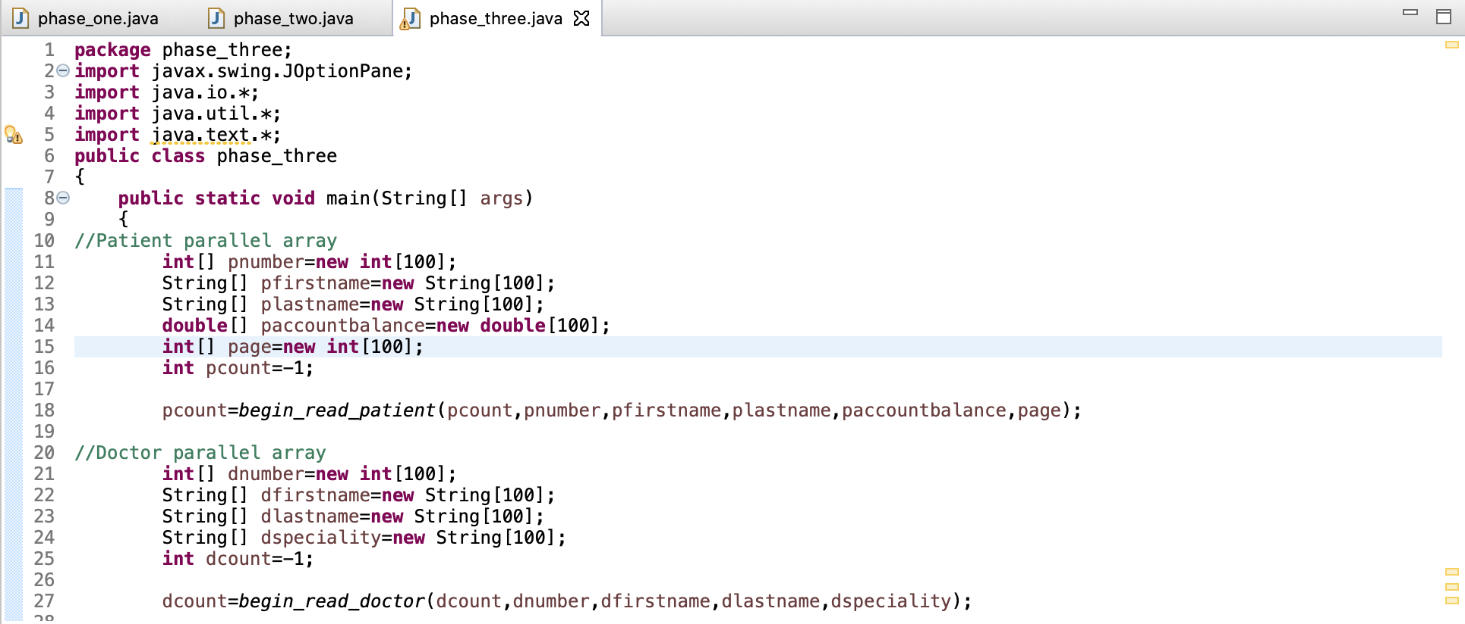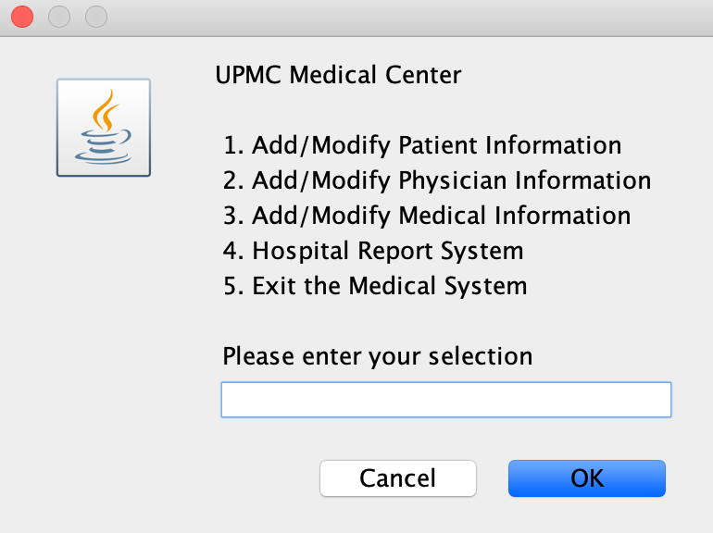

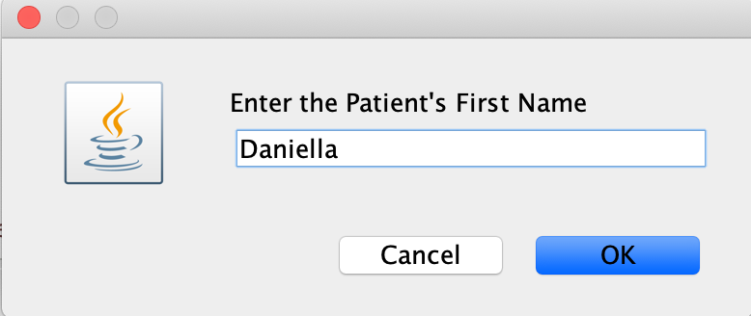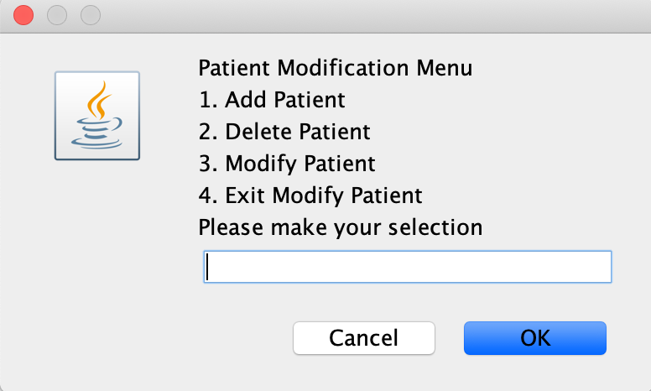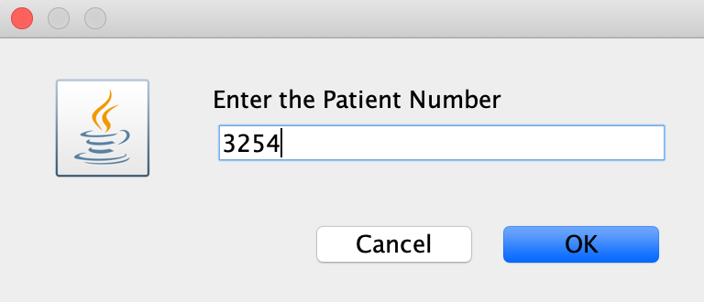

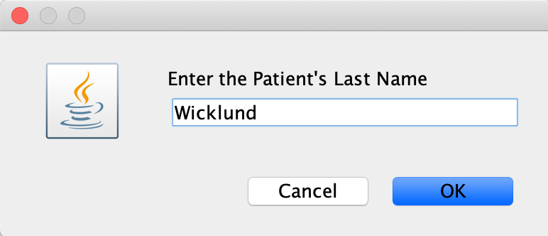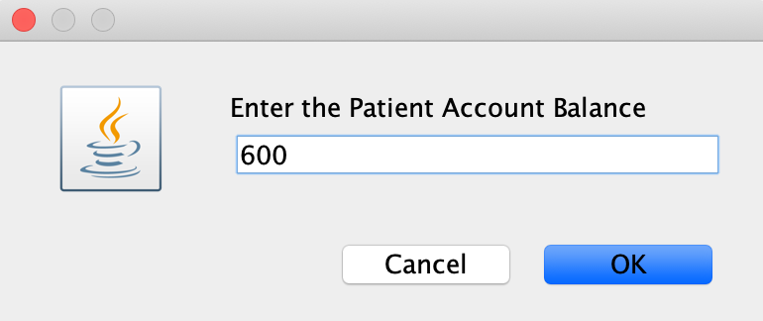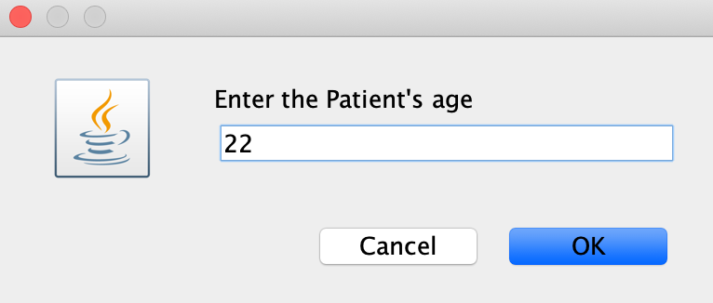

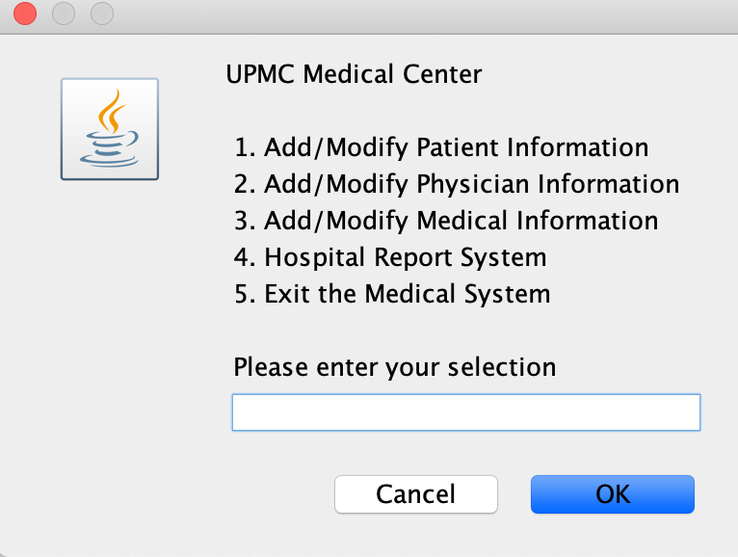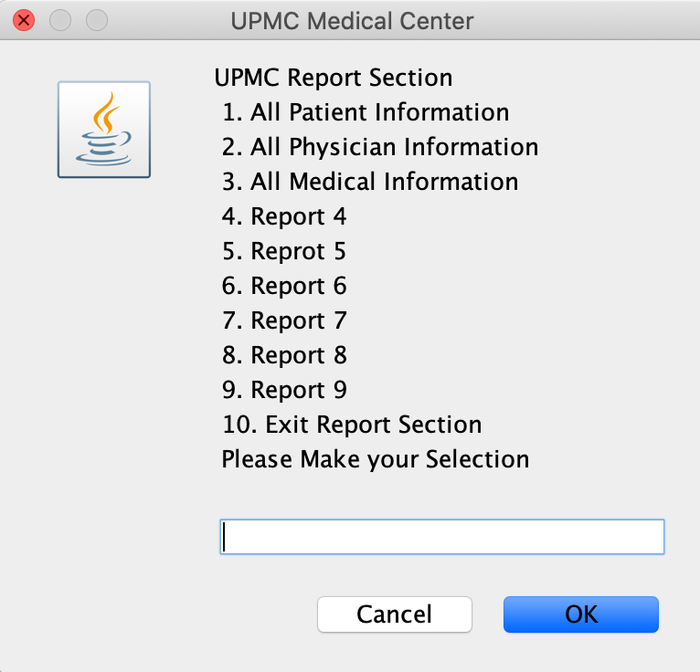

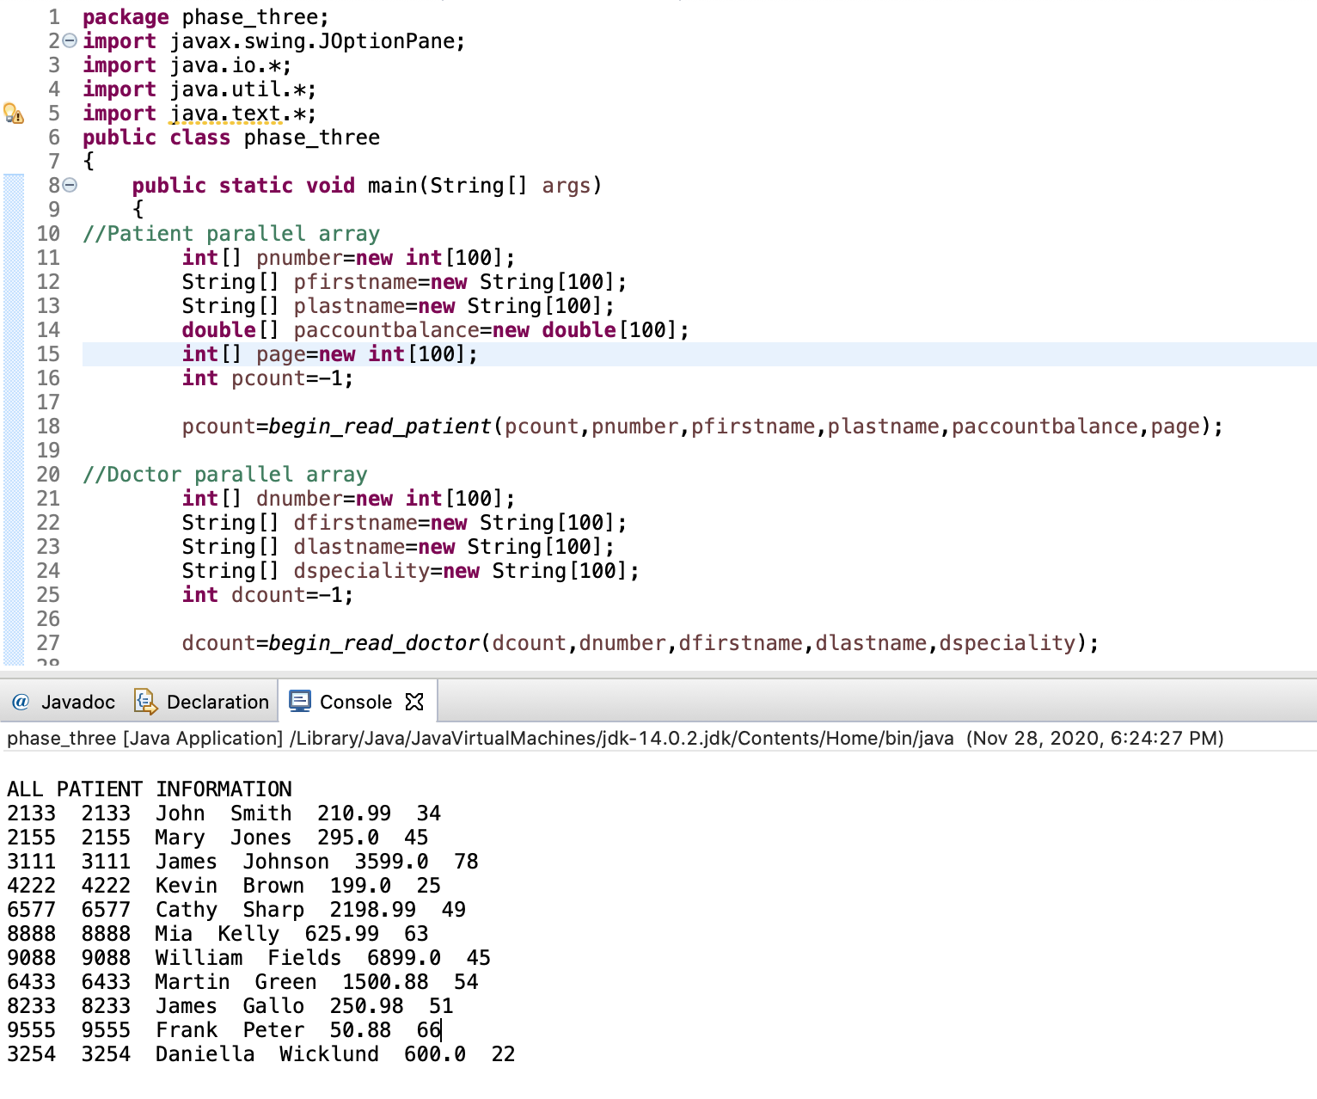

**Physician add section of the code running and Physician Report AFTER modifying values in the arrays**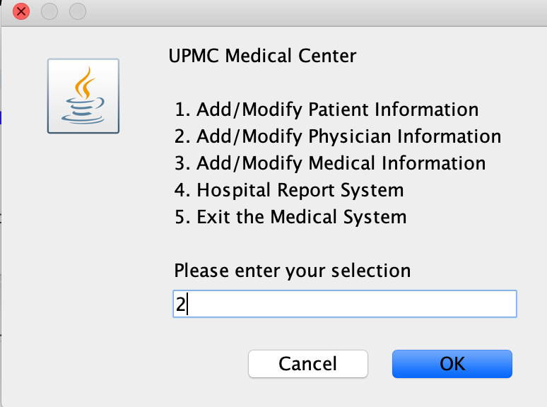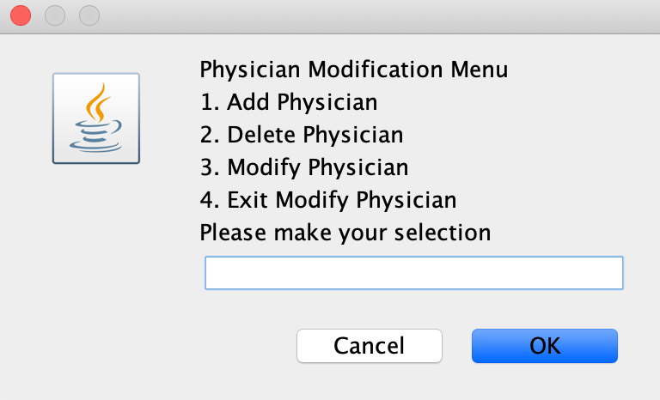

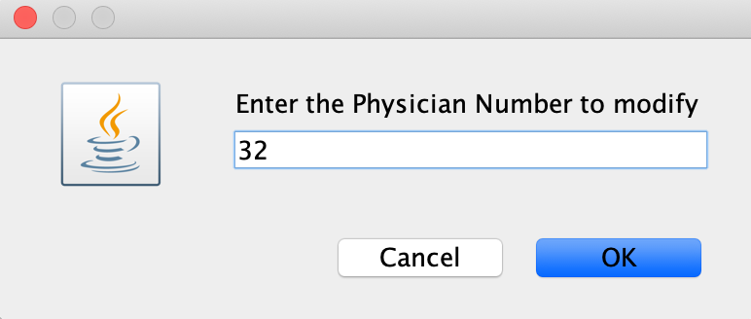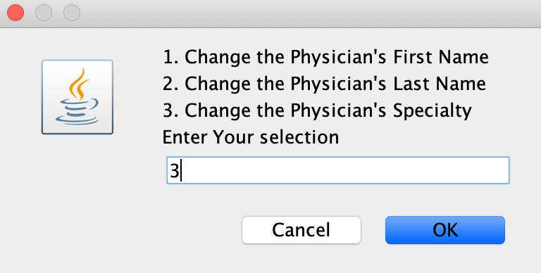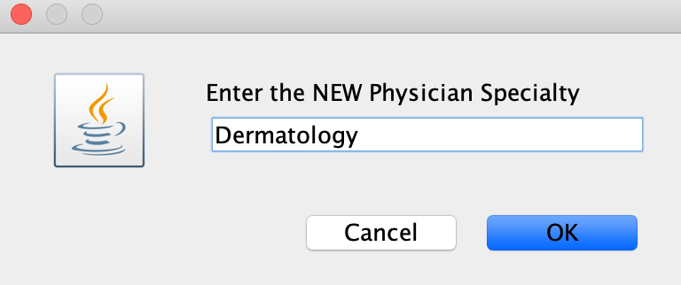

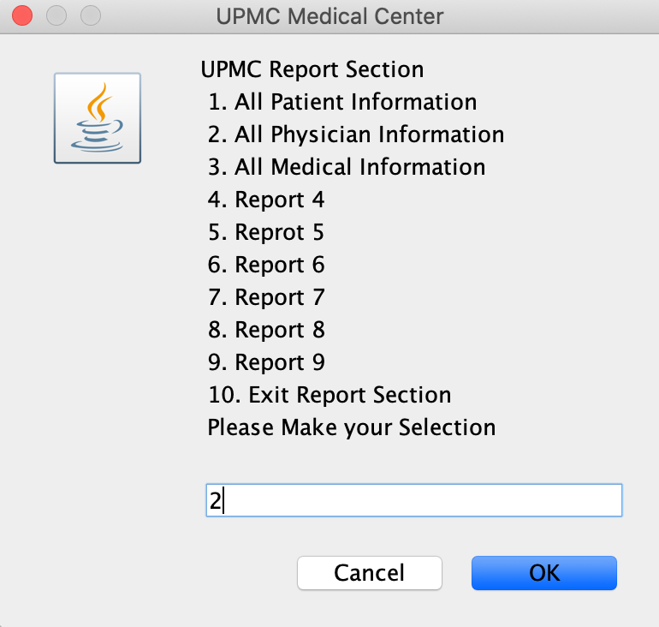

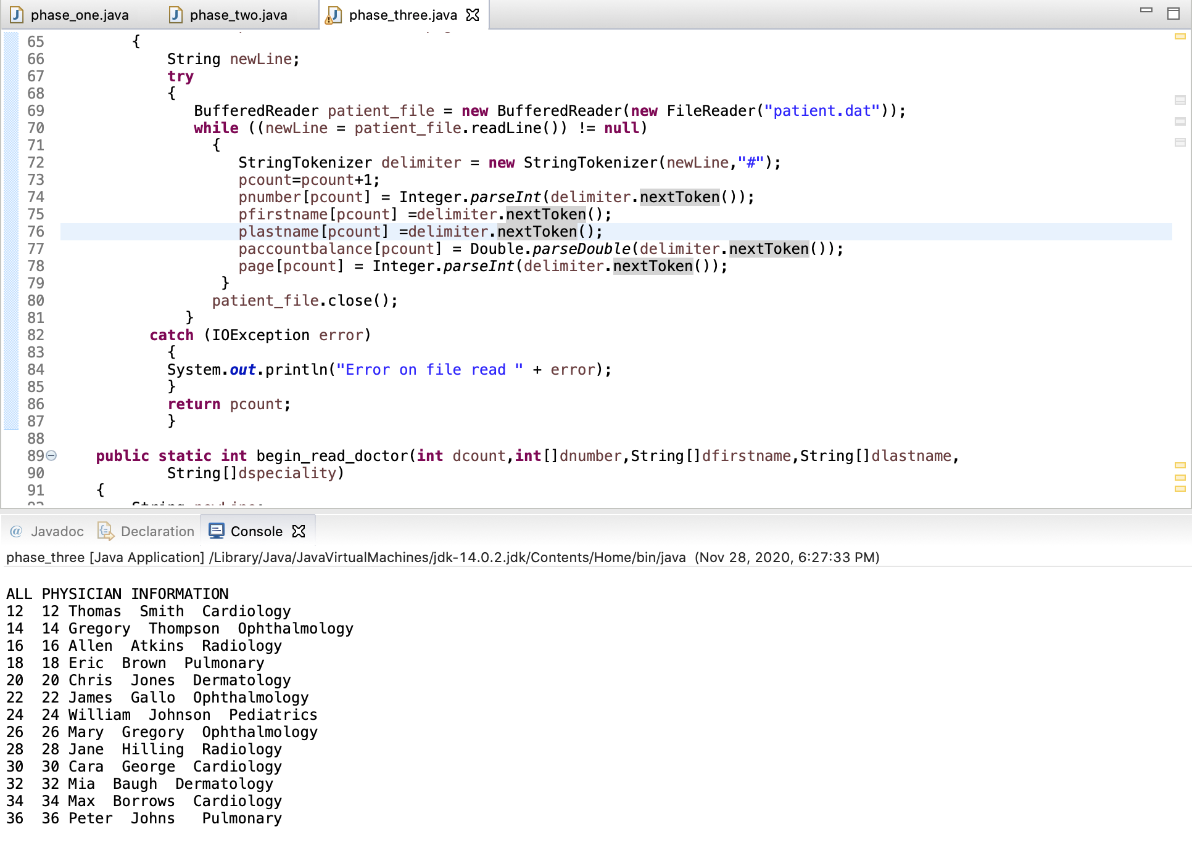

**Medical add section of the code running and Medical Report AFTER adding new values in the arrays**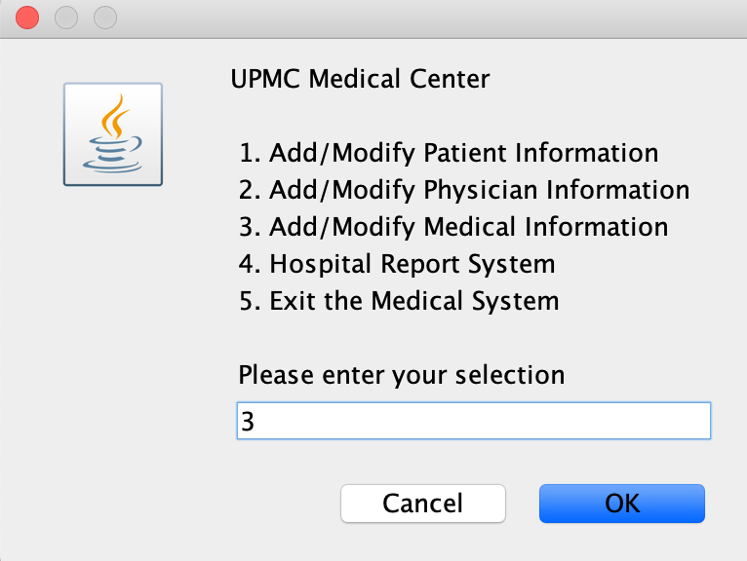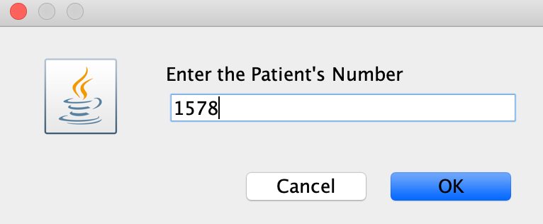

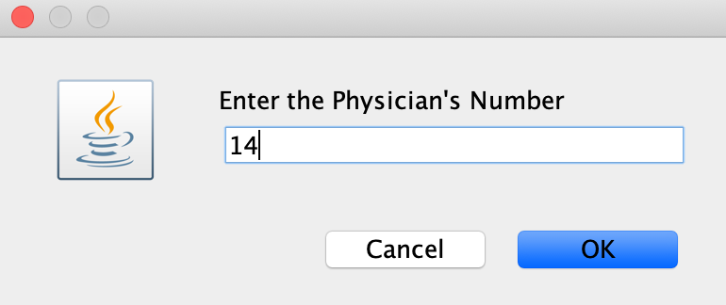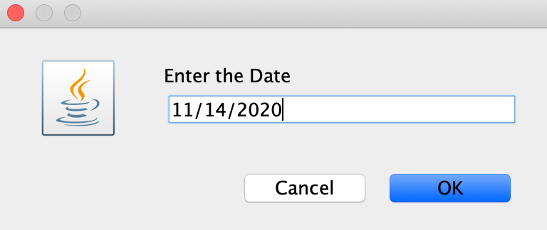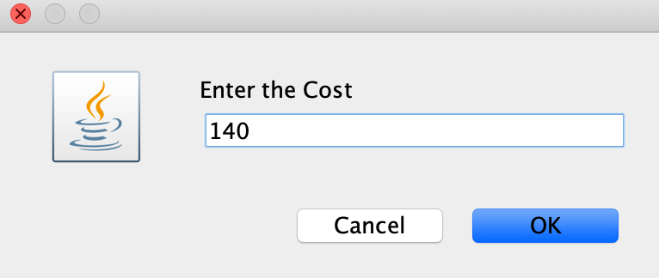

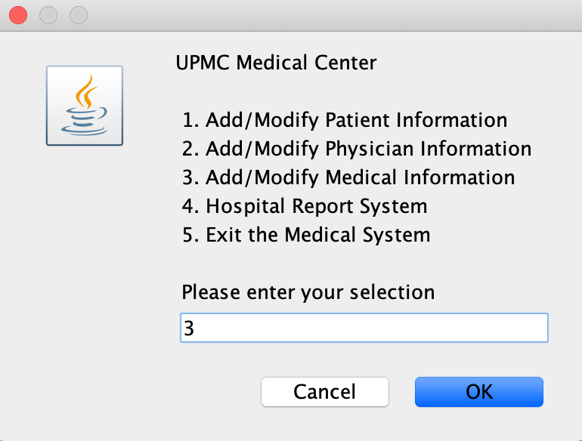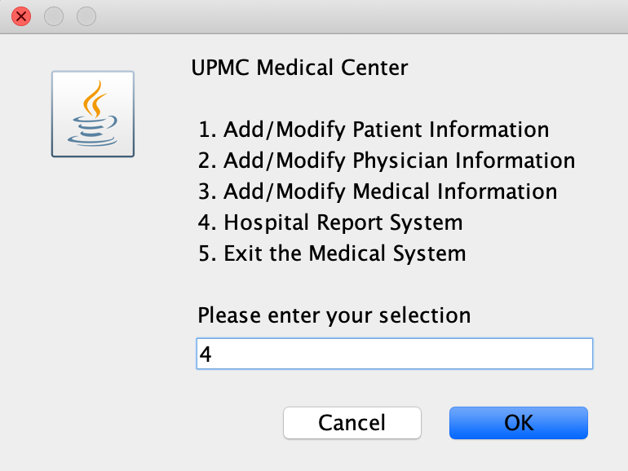

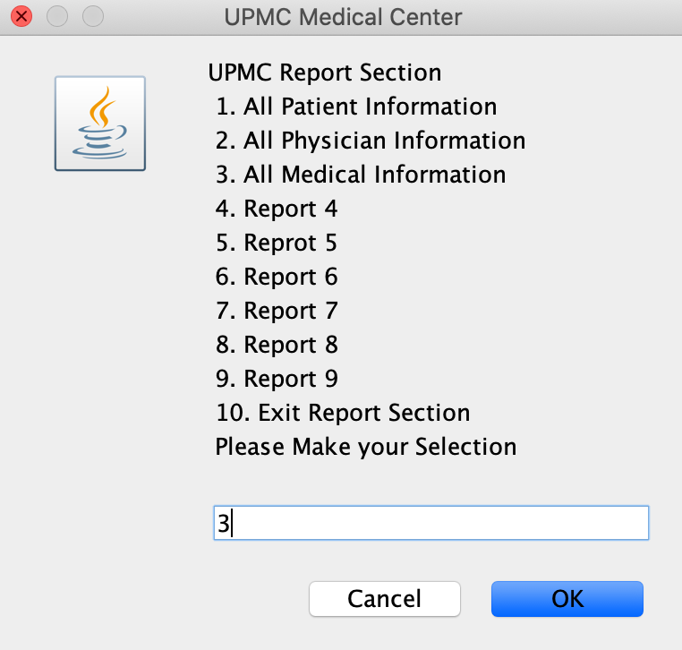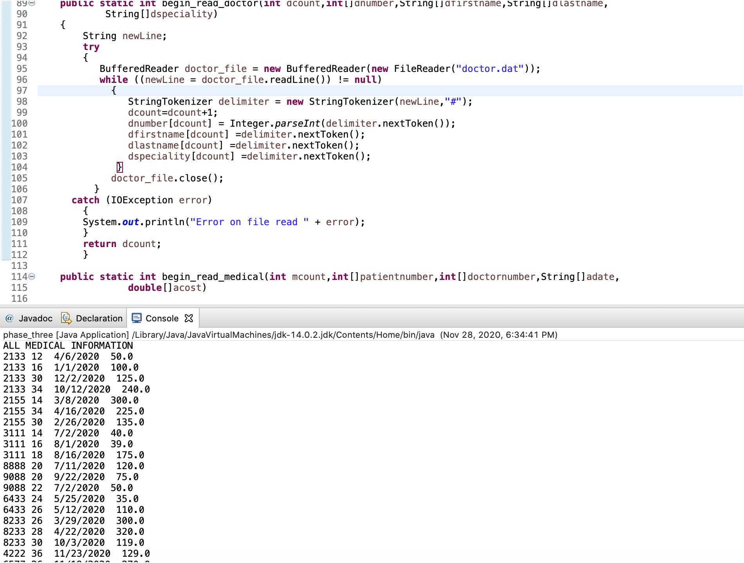

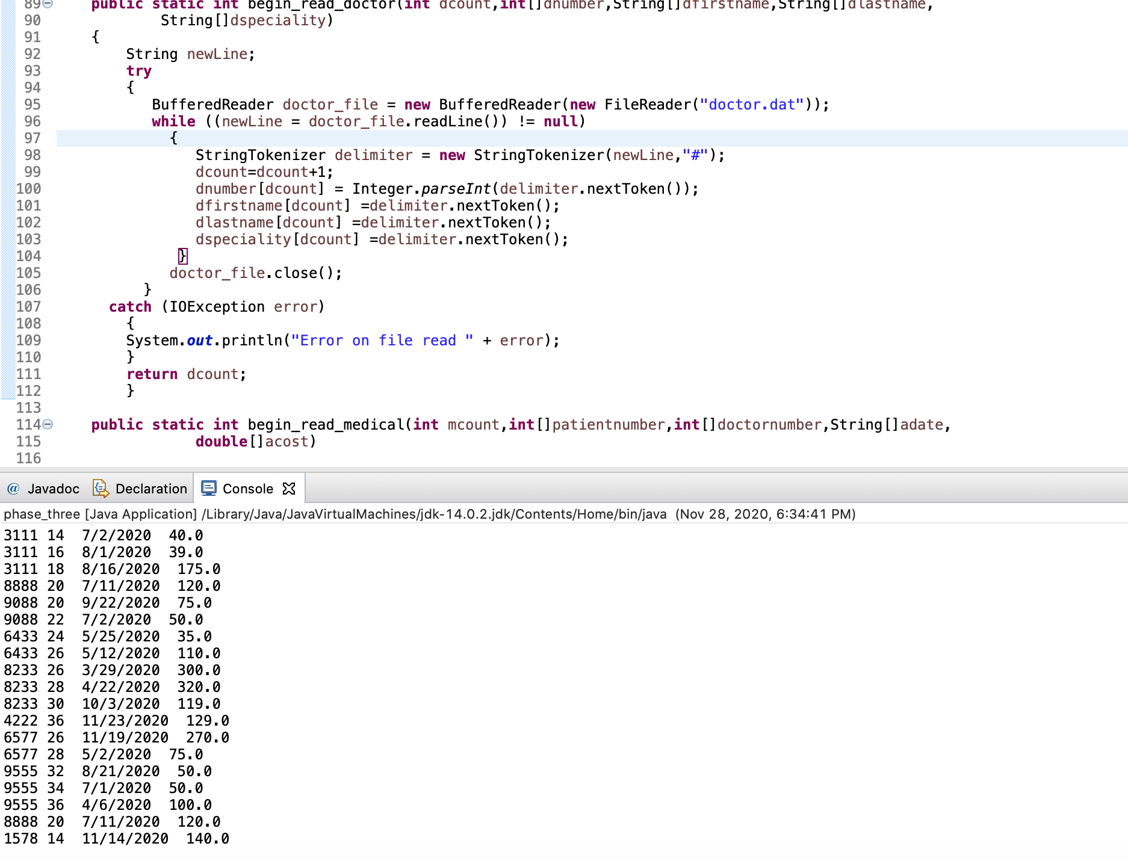

**Patient add section of the code running and Patient Report AFTER deleting values in the arrays**

